Kulshan Environmental Services (KES) 2012 Annual Project Report

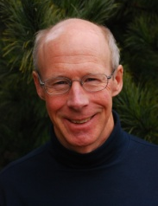
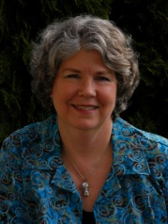
Building a Team
This year we expanded our operations and our staff. Todd Eastman, an environmental planner, joined the company in July to expand our stormwater services program. He is an outstanding researcher and analyst. Allison Roberts also joined our team in September. She is in charge of business development and specializes in website and social media support and editing and document preparation services.
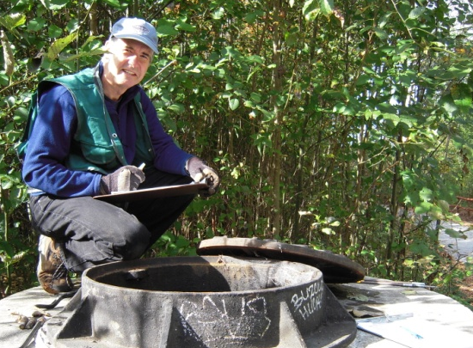
City of Bellingham Stormwater Compliance Project
The City of Bellingham is actively working to reduce impacts from stormwater, particularly in the Lake Whatcom watershed. As part of their comprehensive approach, they contracted with KES to carry out an independent Phase II compliance evaluation for City-owned stormwater facilities. David and Todd spent seven weeks gathering data and preparing a report which the City used for their rate study.

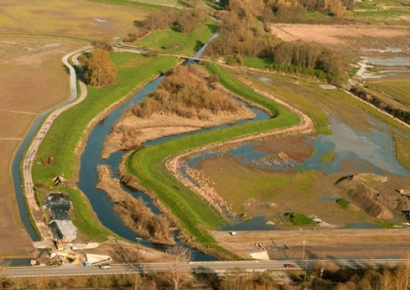
Farms, Fish and Floods Initiative (3FI)
For a second year, KES teamed with Lyn Wiltse of PDSA Consulting to provide facilitation services to the Farms, Fish and Floods Initiative (3FI) in Skagit County. Supported by an EPA grant, this multi-interest group is pioneering mutually beneficial approaches to saving farmland, restoring salmon runs, and reducing flood risk. The group expanded their process to include a broader constituency and several sub-groups to tackle technical issues. David is facilitating the Hydrodynamic Model and Alternatives Analysis subgroup as well as assisting with facilitation of the 3FI project. This process will continue into 2013.

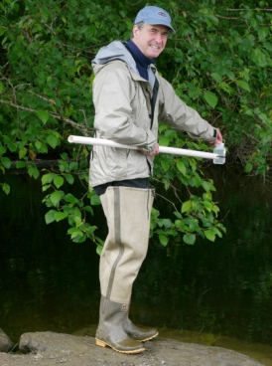
Lake Padden Water Quality Studies
David continued to provide science leadership and program support to People for Lake Padden – a citizen group studying water quality in Lake Padden near Bellingham. This group developed partnerships with Western Washington University’s Institute for Watershed Studies, the City of Bellingham and Whatcom County to complete a series of studies on the health of Lake Padden over the last 18 months. These studies focused on nutrients, algae and fecal coliform in the lake and feeder streams as well as watershed factors contributing to the lake’s current condition. David is currently assisting in the development of recommendations for future lake and watershed management.

Sand Plant Relocation Study
Great Western Supply and Olivine Corporation approached KES to assist with identification of sites to locate a sand crushing facility in Whatcom County. One of the world’s largest olivine deposits exists in Whatcom County. This valuable product is used for a variety of industrial applications. David worked with his client to define key site attributes then utilized zoning information, GIS and local data to identify a series of alternatives for the site.

Watershed Advisory Board Participation
David joined the City of Bellingham’s Watershed Advisory Board in May. The Board advises the City on properties to purchase that have a long-term benefit to the City’s water supply. David brings his years of watershed management and water quality experience to the targeting process.

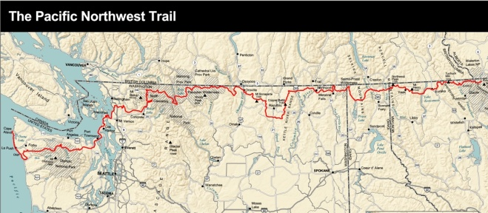
Pacific Northwest Trail Planning
The Pacific Northwest Trail Association and US Forest Service hired PDSA and KES to facilitate stakeholder meetings in 11 locations from Forks, WA to Columbia Falls, MT. A management plan is being developed for the trail system and we assisted with gathering comments and input to the plan. The trail is an ambitious project on the scale of the Pacific Crest Trail and is designed to bring access to natural and to create economic benefit to small cities along the route.
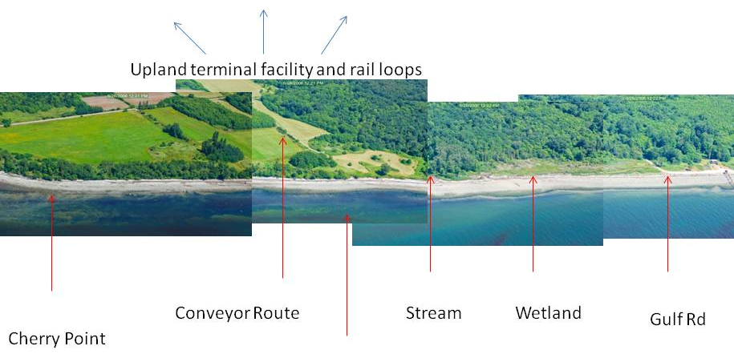
Gateway Pacific Terminal
Salish Law retained KES for David’s extensive knowledge of the Cherry Point site to complete several analyses and develop papers regarding specific environmental concerns. Experience a unique view of the Cherry Point Reach and GPT site with David’s flyover video on YouTube: http://tinyurl.com/cs6dgbd.

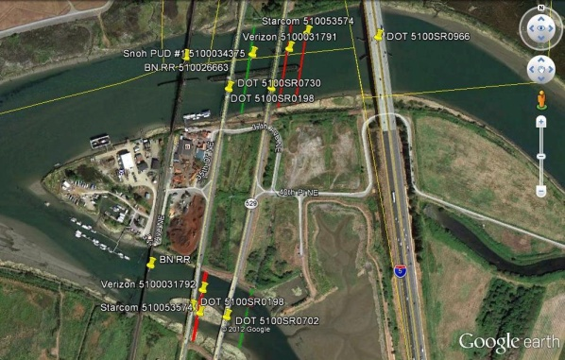

Fiber Optic Cable Crossings
Hired by Blackrock Cable to research easement data at the Department of Natural Resources, KES identified opportunities for cooperative use of easements required for cable crossings over the Snohomish and Stillaguamish Rivers. This resolved issues in completing Blackrock Cable’s service network north and south on the I-5 corridor.

Northwest Marine Trade Association Presentation
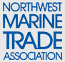
David partnered with staff at Maul, Foster and Alongi to present an interactive workshop outlining the latest regulatory issues that marina owners will need to address in the future. The workshop, “What’s on the Horizon and What you Better Know if you want to Expand or Replace a Facility,” provided a broad understanding of what will be required of future marina and boatyard expansions. David helped to develop the workshop concept and was one of the discussion leaders and technical resource people during the three hour workshop. Using a case study of a proposed facility expansion, participants explored practical solutions to the real world challenges facing operators and owners, including upcoming changes to Washington State permitting requirements.

Stormwater Workshops
David taught two stormwater workshops and led several field tours focusing on emerging maintenance and regulatory obligations for Skagit and Whatcom County homeowners and businesses.

Stormwater Business Development with SCORE
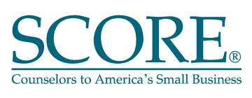
KES continues work with our trusted SCORE advisors Don and Dave who help small businesses find success through entrepreneurship. Through this process we targeted stormwater as a key development area for future business. Our company has been nominated for a SCORE award. (http://www.score.org/news/score-seeks-nominations-4th-annual-score-awards)

Be a Friend - Join our “100 Facebook Friends Campaign”
Get news and insights about stormwater, land use and water issues as well as updates about our business.
“Friend us” on Facebook at Kulshan Environmental Services!

